Practical / Statistical Problems – Aim & Theory

1. Normal Distribution Probability
Aim
To calculate probabilities for a normally distributed random variable using mean and standard deviation.
Theory
A normal distribution is a continuous probability distribution that is symmetric about its mean.
Its probability density curve is bell-shaped.
Formula of standard normal variable:
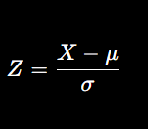
Where:
- (X) = observation
- (\mu) = mean
- (\sigma) = standard deviation
In R:
- pnorm() → cumulative probability
- dnorm() → density
CODE
# (i)
pnorm(27.5, mean=22, sd=5) - pnorm(16.2, mean=22, sd=5)

# (ii)
1 - pnorm(29, mean=22, sd=5)

# (iii)
pnorm(17, mean=22, sd=5)

# (iv)
pnorm(15,22,5) + (1-pnorm(25,22,5))

2. Poisson Distribution (Cars Crossing Bridge)
Aim
To determine the probability of occurrence of events in a fixed interval using Poisson distribution.
Theory
Poisson distribution is used for counting the number of occurrences of rare events over a fixed interval of time or space.
Formula:
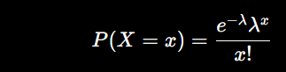
Where:
- (\lambda) = mean number of occurrences
In R:
- ppois() → cumulative probability
- dpois() → exact probability
CODE
1 - ppois(16, lambda=12)

3. Sampling Distribution of Mean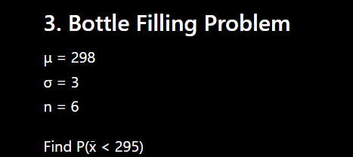
Aim
To find the probability involving sample mean using normal distribution.
Theory
If population is normal, then sample mean follows normal distribution:
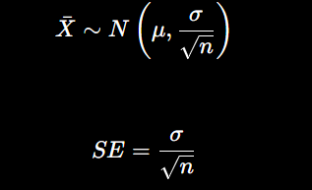

Used when dealing with averages of samples.
CODE
pnorm(295, mean=298, sd=3/sqrt(6))

4. Poisson Distribution with Mean 7
Aim
To calculate cumulative and interval probabilities using Poisson distribution.
Theory
Poisson distribution is suitable when:
- events occur independently
- average rate is constant
- occurrences are rare
Functions used:
- ppois()
- dpois()\
CODE
# (i) P(X < 5)
ppois(4,7)

# (ii) P(X > 10)
1 - ppois(10,7)

# (iii) P(4 < X < 16)
ppois(15,7) - ppois(4,7)

5. One Sample t-Test
Hypothesis Test
Aim
To test whether the population mean differs from a hypothesized mean when population standard deviation is unknown.
Theory
When sample size is small and population SD is unknown, t-test is used.
Test statistic:
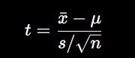
Where:
- (\bar x) = sample mean
- (s) = sample SD
- (n) = sample size
Decision rule:
- Reject (H_0) if p-value < significance level.
CODE
xbar=94.3
mu=100
s=8.4
n=6

t=(xbar-mu)/(s/sqrt(n))
t

pt(t, df=n-1)

6. Z-Test for Mean (Light Bulb)
Aim
To test a claim about population mean when population standard deviation is known.
Theory
Z-test is used when:
- population SD is known
- sample size is large
Formula: 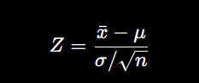
Decision based on p-value or critical value.
CODE
xbar=9900
mu=10000
sigma=120
n=30

z=(xbar-mu)/(sigma/sqrt(n))
z

pnorm(z)

7. Binomial Distribution (Coin Toss) (n=60, p=0.5)
Aim
To calculate probabilities of success in repeated independent trials.
Theory
Binomial distribution applies when:
- fixed number of trials
- only two outcomes
- trials are independent
- probability remains constant
Formula: 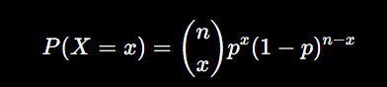
In R:
- dbinom() exact probability
- pbinom() cumulative probability
CODE
# (i) 20,25 or 30 times
dbinom(20,60,0.5)+dbinom(25,60,0.5)+dbinom(30,60,0.5)

# (ii) less than 20
pbinom(19,60,0.5)

# (iii) between 20 and 30
pbinom(30,60,0.5)-pbinom(19,60,0.5)

8. Binomial Distribution (Successes) (n=10, p=0.6)
Aim
To determine the probability of a fixed number of successes.
Theory
Binomial distribution models repeated Bernoulli trials.
Parameters:
- (n) = number of trials
- (p) = probability of success
CODE
dbinom(5,10,0.6)

9. Hypothesis Test for (Cookie Fat)
Aim
To test whether the mean saturated fat exceeds the labeled amount.
Theory
Hypothesis testing compares sample evidence with population claim.
Steps:
- State hypotheses
- Compute test statistic
- Find p-value
- Make decision
CODE
xbar=2.1
mu=2
s=0.3
n=35

t=(xbar-mu)/(s/sqrt(n))
t

1-pt(t,df=n-1)
CONCLUSION :reject H0

10. Employee Late Probability (n=5, p=0.4)
Aim
To calculate probabilities using binomial distribution.
Theory
Each employee can either:
- be late
- not be late
Thus, binomial distribution is appropriate.

11. Descriptive Statistics
Aim
To obtain summary statistics of a dataset using R/Excel.
Theory
Descriptive statistics summarize and describe data.
Important measures:
- Mean
- Median
- Variance
- Standard deviation
- Minimum
- Maximum
Functions in R:
- mean()
- sd()
- var()
- summary()
CODE
x=c(
16.2,16.8,15.9,15.6,15.9,16.6,
15.8,16,16,15.7,15.9,15.6,
15.8,16.4,16.3,16,16.8,15.6,
15.8,15.2,16,16.2,15.4,16.9,
16.3,15.9,16.4,16.1,15.7,16.3
)

summary(x)
mean(x)
sd(x)
var(x)

12. Penguin Weight Hypothesis Test
CODE
xbar=14.6
mu=15.4
sigma=2.5
n=35

z=(xbar-mu)/(sigma/sqrt(n))
z

2*pnorm(z)
CONCLUSION : fail to reject H0
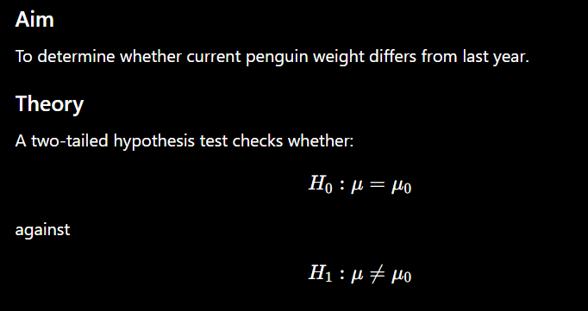

13. Sampling Distribution Problem (Mean=8000 SD=3200 n=64)
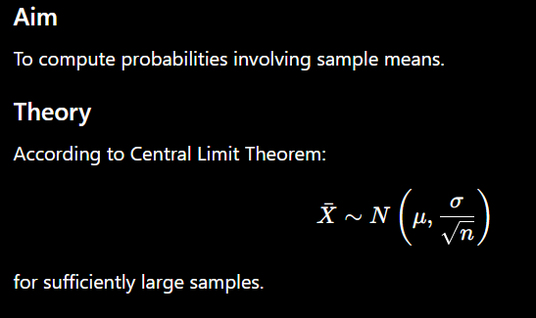
CODE
# P(xbar > 9000)
1-pnorm(9000,8000,3200/sqrt(64))

# P(xbar < 8500)
pnorm(8500,8000,3200/sqrt(64))

14. Probability for Sample Mean (Mean=18 SD=4.8)
Aim
To calculate probabilities for sample averages from normal distribution.
Theory
Sampling distribution helps estimate probabilities for sample means rather than individual observations.
CODE
# i
pnorm(16,18,4.8/sqrt(25))

# ii
1-pnorm(16,18,4.8/sqrt(25))

# iii
pnorm(20,18,4.8/sqrt(25))

15. Binomial Distribution (n=10, p=0.45)
Aim
To evaluate exact and cumulative probabilities using binomial distribution.
Theory
Binomial probabilities are computed for independent repeated trials with constant probability of success.
CODE
# a
dbinom(8,10,0.45)
# b
1-pbinom(4,10,0.45)
# c
pbinom(6,10,0.45)

16. Multiple Choice Quiz Problem
Aim
To find probability of correct answers guessed randomly.
Theory
Since each question has:
- success = correct answer
- failure = wrong answer
Binomial distribution applies.
Probability of success: 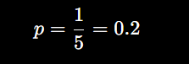
CODE
pbinom(4,12,0.2)

17. HITAVADA Press Life Test
Aim
To test whether the average press life is less than the hypothesized value.
Theory
A left-tailed z-test is used because:
- population SD is known
- claim is “less than”
CODE
xbar=13000
mu=14500
sigma=2100
n=25

z=(xbar-mu)/(sigma/sqrt(n))
z

pnorm(z)

18. LEGO Toy Weight Problem
Aim
To calculate probability for a normally distributed variable exceeding a value.
Theory
Normal distribution probabilities are computed using z-scores.

CODE
1-pnorm(19,17.46,sqrt(375.67))

19. One Sample t-Test (Mean = 70)
Aim
To test whether the population mean is greater than the hypothesized mean.
Theory
A right-tailed t-test is used when:
- sample size is small
- population SD unknown
- alternative hypothesis is “greater than”
CODE
xbar=83
mu=70
s=12.5
n=22

t=(xbar-mu)/(s/sqrt(n))
t

1-pt(t,df=n-1)
CONCLUSION reject H0

20. Exam Score Normal Distribution
Aim
To determine percentage of students scoring above a given mark.
Theory
When exam scores follow normal distribution, probabilities are computed using standard normal transformation.
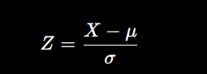
Then probabilities are obtained using normal distribution tables or pnorm() in R.
CODE
1-pnorm(84,72,15.2)

